DIGITEK SYSTEM INTERNATIONAL INC DYNAMIC BUSINESS SOLUTION
KOREA INDIA

PRESENTS

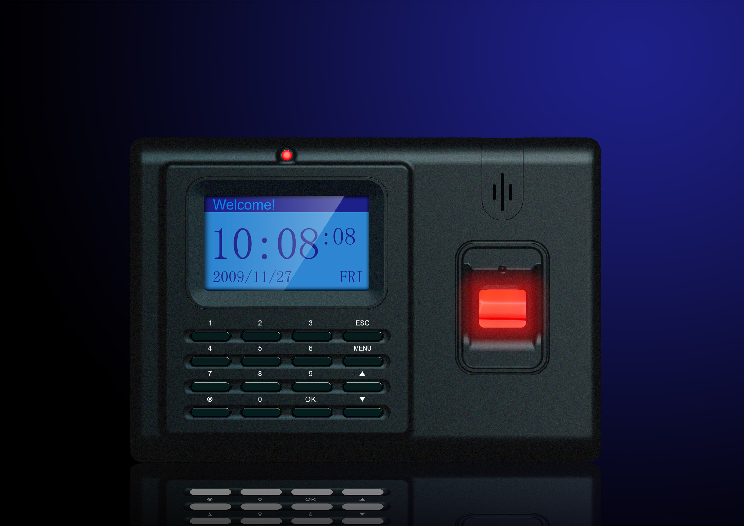
DTK 400

PARAMETERS

USER CAPACITY | 2,000
TRANSACTION STORAGE | 52,000
VERIFICATION MODE | 1:1 , 1:N
FAR | <.0001%
FRR | <.01%
STAFF ID | 5 DIGITS
STAFF NAME | 8 DIGITS
Communication | TCP/IP, Wigand, USB
ALARM CLOCK | Embedded Alarm Clock
ACCESS CONTROL SYSTEM | YES
POWER SUPPLLY | 12 V 1 Amp
CARD READER | Proximity card reader
CENSOR | Scratch less ,Dust free
SHOW | Time, ID, NO, Name
Working Mode | Finger Print , Password, Card

KEY FEATURES

Korean design , Data transfer through SD card , Access control system by use of external power supply , TCP/IP as well as USB plug & play connectivity, Battery backup (optional),3,000 users (optional), Very fast Identity system, Scratch less & dust free Sensor, Time Zone facility-Specific time zone for door open can be set for specific user , Easy to use T & A software , SDK available, CE & ROHS certified.

About Digitek System International INC –
DIGITEK is Korea based company & is leader in Biometric solution, In a world of digital revolution, where the technology is reaching out and touching our lives in almost every sphere, DIGITEK has emerged as a leading supplier of end-to-end solutions for the technology platforms of Smart Cards, Biometrics, Radio Frequency Identification and IP Surveillance. Digitek innovative and most outstanding biometric solutions for corporate and organizations across the system. DIGITEK is uniquely focused on delivering Biometric security based enterprise-wide applications designed from ground up for the SME and Large market. These applications are extremely cost effective, feature-rich and user friendly. Users can start with an off-the-shelf

office

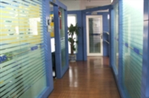
R&D center
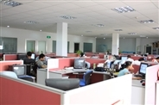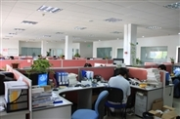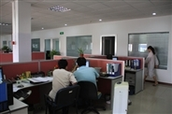

production line
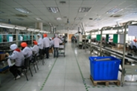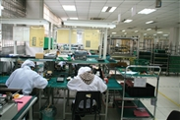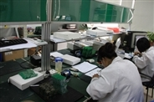

SMT
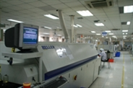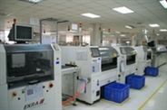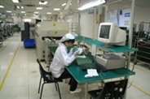

DYNAMIC BUSINESS SOLUTION
K-37/1 , Krishna park ext,
Street no -13, Tilaknagar,NewDelhi-18
Ph-+91-11-25990231
www.dbsindia.in

