DIGITEK SYSTEM INTERNATIONAL INC DYNAMIC BUSINESS SOLUTION

PRESENTS

DTK 300 ACCESS

PARAMETERS

Screen L*W mm | 122*34 LCD
Identification time | <1s
Fingerprint Capacity | 3,000
Log Capacity | 80,000
Temperature | 0C-50C
Power | DC12V
Voltage range | 100v~240V
FAR | ≤0.0001%
FRR | ≤1%
Language | English
Communication Protocols | TCP/IP,RS232/485,
Access Control | 50 time zones,5 time groups,10 opening combinations, tamper alarm, exit button, bell button embedded,door sensor,etc,
Machine size (L*W*H mm) | 130*88*38
Packing (L*W*H mm) | 27*18*12
Optional Function | ID or IC card reading

KEY FEATURES

Korean design , Dedicated access control system, external Proximity card (WG26) can be attached for exit use , Data transfer TCP/IP , 3,000 users , Very fast Identity system, Scratch less & dust free Sensor, Time Zone facility-Specific time zone for door open can be set for specific user , Easy to use T & A software , SDK available, CE & ROHS certified.

About Digitek System International INC –
DIGITEK is Korea based company & is leader in Biometric solution, In a world of digital revolution, where the technology is reaching out and touching our lives in almost every sphere, DIGITEK has emerged as a leading supplier of end-to-end solutions for the technology platforms of Smart Cards, Biometrics, Radio Frequency Identification and IP Surveillance. Digitek innovative and most outstanding biometric solutions for corporate and organizations across the system. DIGITEK is uniquely focused on delivering Biometric security based enterprise-wide applications designed from ground up for the SME and Large market. These applications are extremely cost effective, feature-rich and user friendly. Users can start with an off-the-shelf

office

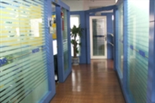
R&D center
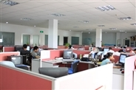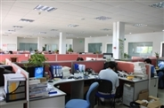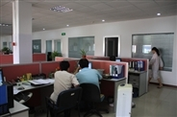

production line
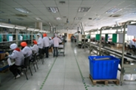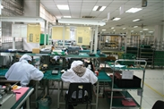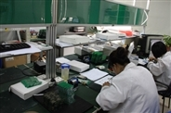

SMT
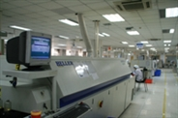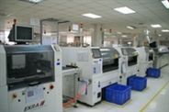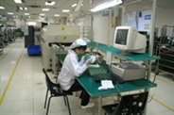

DYNAMIC BUSINESS SOLUTION
K-37/1 , Krishna park ext,
Street no -13, Tilaknagar,NewDelhi-18
Ph-+91-11-25990231
www.dbsindia.in

