DVR USB 3G moulde function Introduction
1. Name: USB 3G module
2. Function introduction:
Add wireless network,user can view remote based on 3G
3.Notice:
a.
Our dvr support basic 3G module function,as there are many different series 3G module in different market,different series must with different driver,we can not match all drive.But we are always developing,adding more and more 3G into our compatible listt
b.
If user want to connect with dvr by 3G function(such as IP address,DDNS,Eseenet),need to use 3G SIM card which support direct-connection,such kind of SIM card or service is offered by network serve.Any confusion,please contact with ur local network serve
c.
Network speed depends on 3G network environment and 3G module performance
d.Once 3G function starts,dvr will use 3G netwoek defult,Eseenet/DDNS will switch to 3G mode automatically
It might happen expensive network flow,pls pay attention.Besides,if you close 3G,you can also use network cable for Internet
4.Function use restrict and notice:
Firstly,prepare below details:
1). Confirm SIM card is 3G card or not,compatible with 3G module or not
2). Confirm 3G module you are using are in compatible list,if beyond,your 3G module might can not use because of compatible reason
3). Insert SIM card into 3G module,then insert 3G module into dvr USB,turn on power,enter main menu---setting---network setting.Check 3G sconnection status,if show USB 3G moudle Not Found,then check 3G module connection.You can take it out,then insert again
4). If some times checking,still not found,this 3G module might can not use because of compatible reason
5. 3G Enable and setting
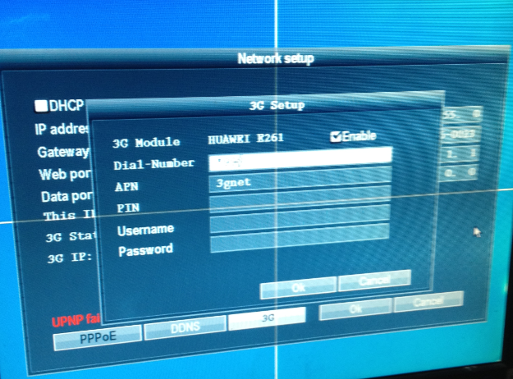
1).Enter main menu---setting---network setting---3G setting
2).Settting correctly:dial-number/APN/PIN/username/password
3).Dial-number/APN is required,PIN/username/password no need to input
4).PIN encrypt SIM card,before using this card,input 4 digits password
Above setting is related to your local 3G network serve,you can inquery them
5). Above setting done and save,then reboot dvr,3G function will activate,it takes around 20 secons to 1 minute.When it shows connected in 3G status,3G is on
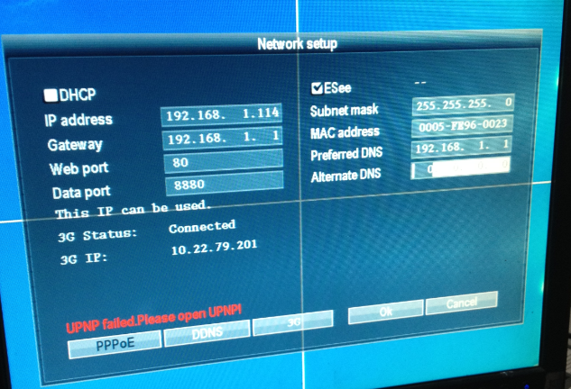
6).Next time,dvr will detect 3G module,and activate automatically

Compatible 3G module list
1.Compatible 3G module:
Huawei E261
Huawei E1732
2.Might Compatible 3G module:
Huawei K3770
Huawei K3771
Huawei K4510
Huawei E169
Huawei E173
Huawei E180
Huawei E220
Huawei E230
Huawei E270
Huawei E352
Huawei E870

